A PROSPECTIVE STUDY ON CLINICAL PREDICTORS OF PENETRATING CHEST INJURY

JONATHAN R. MALABANAN, MD.¹

EDGARDO PENSERGA MD. FPCS

REYNALDO JOSON, MD, MHA, MHPED, MS SURG

Department of Surgery
Ospital ng Maynila Medical Center

¹ Reprint requests: Jonathan R. Malabanan. M.D., Department of Surgery, Ospital ng Maynila Medical Center, Quirino Ave, Malate, Manila, Philippines
Email: ommcsurgery@yahoogroups.com

Abstract
Background: With a history of trauma to the chest, one usually thinks of penetration to the chest cavity and involvement of underlying structures. Physicians usually request Chest X-ray looking for presence of pneumothorax or hemothorax. There is no reliable clinical predictors exist to effectively diagnose a penetrating chest injury. Objective: This paper aims to come out with reliable set of clinical predictors of penetrating chest injury. Methodology: Seventy four patients with history of trauma to the chest were enrolled in the study. The predictive power of shortness of breath, subcutaneous emphysema and abnormal auscultation were validated and chest x- ray result is used as the gold standard. Cross tabulation and Pearson r test are used for statistical analysis. Results: shortness of breath is strongly correlated with pneumohemothorax with an r value of 0.882. Subcutaneous emphysema has no correlation with pneumohemothorax with an r value of -0.197. Abnormal auscultation is strongly correlated with pneumohemothorax with an r value of 0.987. Shortness of breath and abnormal auscultation has a positive predictive value of 1. Subcutaneous emphysema has a predictive value of 0.13. Conclusion: the presence of either shortness of breath or abnormal auscultation is sufficient in determining whether a chest injury is penetrating or not.

INTRODUCTION
A number of diagnostic and treatment modalities have come under scrutiny regarding both their utility in patient care and their cost effectiveness. There are a number of studies demonstrating that routine radiographs are not necessary in the awake and alert trauma patient, and may unnecessarily misappropriate hospital resources. Several investigators have reported that in the absence of various clinical indicators, elimination of these x-rays does not compromise patient care or lead to an increase in missed injuries or delay in diagnoses.
There is no reliable clinical predictors exist to effectively diagnose a penetrating chest injury in the absence o f X-ray. Hence there is a need for hard evidence supported by a well documented research study regarding clinical predictors in penetrating chest injury.
At present there are only a few published papers in the literature that deal with the said topic. These papers are all done abroad. Despite the presence of published papers in the world literature, the authors thought it necessary and worthwhile to conduct another study on the same topic in the Philippines.

METHODOLOGY
Design: Prospective cases starting January 2007.
Setting: OMMC, Department of Surgery
Inclusion criteria:
All patients both males and females 16 year old and above seen starting January 2008 who came in our institution presenting with suspected intrathoracic injury by virtue of stab wound, punctured and gunshot wound who received chest radiographs were prospectively enrolled in this study.
Exclusion criteria were age less than 15 years old, trauma more than 72 hours before presentation, patients with avulsion and laceration, and GCS score less than 15. Before Chest radiographs were done; the following data were recorded: difficulty of breathing, subcutaneous emphysema and abnormal chest auscultation.

DEFINITION OF TERMS
Penetrating Chest Injury= injury to the chest with the outside source penetrating the chest wall, heart, lungs, thoracic aorta and great vessels as evidenced by pneumothorax and hemothorax.
Pneumothorax= accumulation of air or gas on the pleural cavity.
Hemothorax= accumulation of blood on the pleural cavity.
Stab wound= type of open wound usually caused by a knife and other sharp objects.
Punctured wound= type of open wound caused by a pointed object puncturing the skin
Subcutaneous Emphysema= refers to crackling sensation felt under the skin wherein the air is trapped.
Laceration= type of open wound with irregular borders caused by a blunt impact to soft tissue or tearing of skin and other tissues.
Abrasion= superficial wound in which the epidermis is scraped off.
RESULTS TABLE
Patient Tally Sheet
Table 1. Total number of Patients with Penetrating and Non- penetrating Chest Injury from January to June 2008
Month | Total No. of Patients | Penetrating | Non-penetrating
Jan | 11 | 5 | 6
Feb | 10 | 3 | 7
Mar | 15 | 7 | 8
April | 18 | 10 | 8
May | 11 | 6 | 5
June | 9 | 5 | 4
Total | 74 | 36 | 38

Table 2. Frequency Distribution Signs and Symptoms vs. Chest X- ray Findings
Month | Signs and Symptoms |  |  | Chest X- ray Findings
 | Shortness of Breath | Subcutaneous  Emphysema | Abnormal Auscultation | (+)  With Pneumonia/ hemothorax | (-)  Without Pneumo/ hemothorax
Jan | 6 | 1 | 5 | 5 | 6
Feb | 7 | 2 | 5 | 5 | 5
Mar | 7 | 1 | 7 | 7 | 8
April | 10 | 1 | 8 | 9 | 9
May | 6 | 0 | 6 | 6 | 5
June | 5 | 1 | 5 | 5 | 4

Correlations

 |  | Sob | P/H
Shortness of Breath | Pearson Correlation | 1 | .882(*)
Shortness of Breath | Sig. (2-tailed) | . | .020
Shortness of Breath | N | 6 | 6
With Pneumo/ hemothorax | Pearson Correlation | .882(*) | 1
With Pneumo/ hemothorax | Sig. (2-tailed) | .020 | .
With Pneumo/ hemothorax | N | 6 | 6
* Correlation is significant at the 0.05 level (2-tailed).

Correlations

 |  | subQ | P/H
Subcutaneous Emphysema | Pearson Correlation | 1 | -.197
Subcutaneous Emphysema | Sig. (2-tailed) | . | .708
Subcutaneous Emphysema | N | 6 | 6
With Pneumo/ hemothorax | Pearson Correlation | -.197 | 1
With Pneumo/ hemothorax | Sig. (2-tailed) | .708 | .
With Pneumo/ hemothorax | N | 6 | 6

Correlations

 |  | Abnormal Auscultation | P/H
Abnormal Auscultation | Pearson Correlation | 1 | .987(**)
Abnormal Auscultation | Sig. (2-tailed) | . | .000
Abnormal Auscultation | N | 6 | 6
With Pneumo/ hemothorax | Pearson Correlation | .987(**) | 1
With Pneumo/ hemothorax | Sig. (2-tailed) | .000 | .
With Pneumo/ hemothorax | N | 6 | 6
** Correlation is significant at the 0.01 level (2-tailed).

Table 3. r value of Signs and Symptoms
 | r value | Remarks
Shortness of Breath | 0.882 | strongly correlated
Subcutaneous Emphysema | -0.197 | no correlation
Abnormal Auscultation | 0.987 | strongly correlated

Table 4. Predictive value of Shortness of Breath VS. presence of
Pneumo/hemothorax

 | (+) Pneumo /hemothorax | (-)Pneumo /hemothorax | Total
(+) SOB | 38 | 4 | 42
(-) SOB | 0 | 32 | 32
Total | 38 | 36 | 74
 | positive PV | 1.000
 | negative PV | 0.88888889

Table 5. Predictive value of Subcutaneous Emphysema VS. presence of
Pneumo/hemothorax

 | (+) Pneumo /hemothorax | (-)Pneumo /hemothorax | Total
(+) subQ | 5 | 1 | 6
(-) subQ | 32 | 36 | 68
Total | 37 | 37 | 74
 | positive PV | 0.135
 | negative PV | 0.97297297

Table 6. Predictive value of Abnormal Auscultation VS. presence of
Pneumo/hemothorax

 | (+) Pneumo /hemothorax | (-)Pneumo /hemothorax | Total
(+) abn A | 36 | 1 | 37
(-) abn A | 0 | 37 | 37
Total | 36 | 38 | 74
 | positive PV | 1.000
 | negative PV | 0.97368421

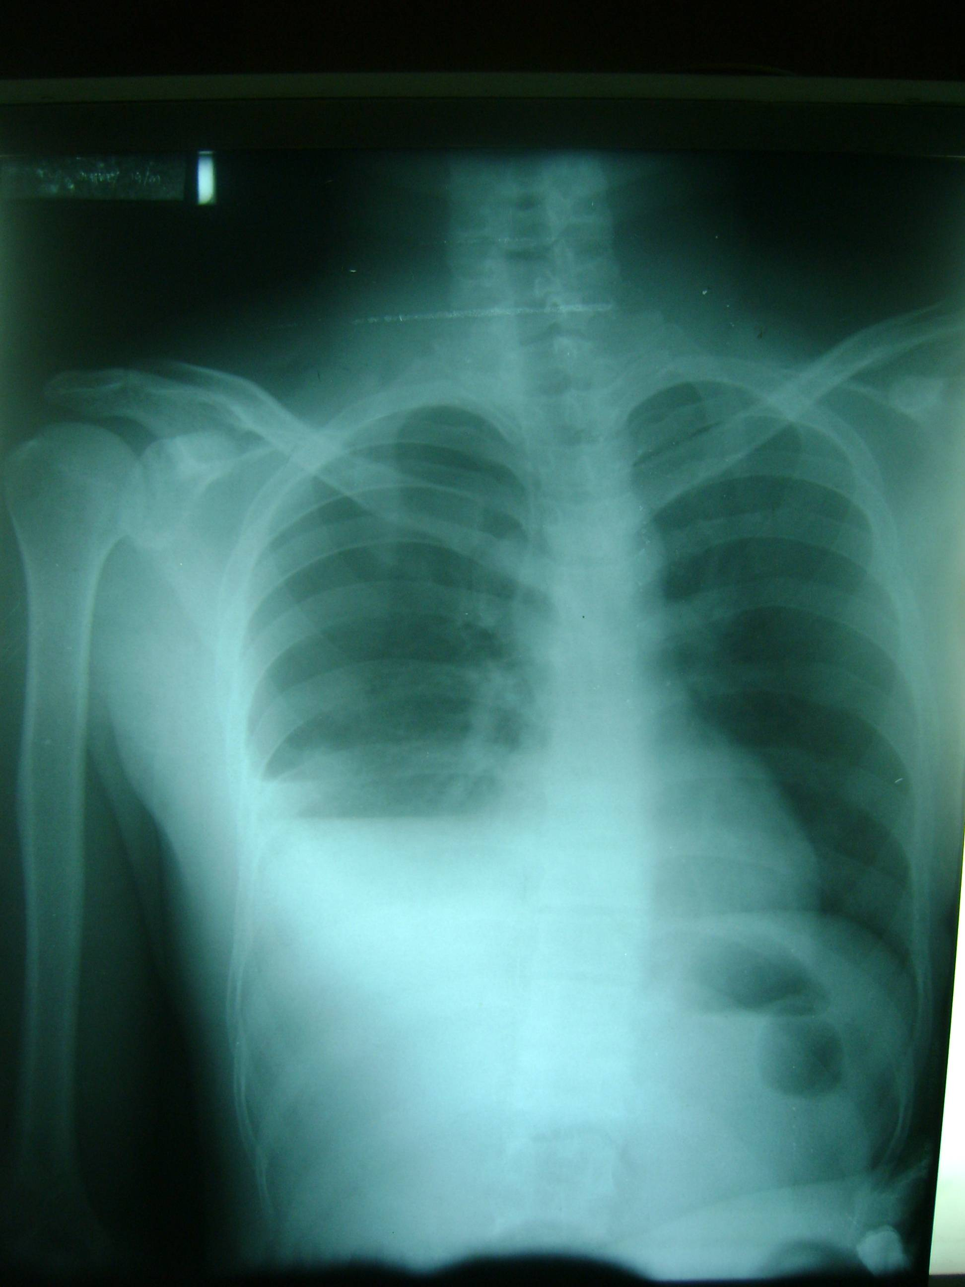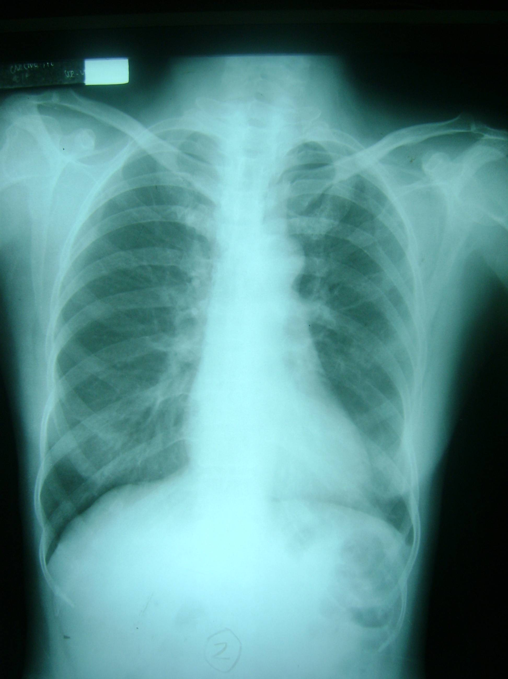
Fig.1 Fig.2
DISCUSSION
During the 6-month study period, data were acquired on seventy four patients. All of them presented with suspected intrathoracic injury by virtue of stab wound, punctured and gunshot wound. The predictive power of shortness of breath, subcutaneous emphysema and abnormal auscultation were validated and chest x- ray result was used as the gold standard. Thirty six patients sustained penetrating chest injury as evidenced by pneumohemothorax on Chest X- ray. (Fig.1)
With the presence of pneumohemothorax, correlations between each clinical predictor were validated using person r test and SPSS data processor. Shortness of breath has strong correlation with pneumohemothorax with an r value of 0.882. Subcutaneous emphysema has no correlation with pneumohemothorax with an r value of -0.197. The negative value can be attributed to a single patient who initially presented with subcutaneous emphysema, negative for pneumohemothorax, then spontaneously resolved. (Fig.2) Abnormal auscultation has strong correlation with pneumohemothorax with an r value of 0.987. Shortness of breath and abnormal auscultation has a positive predictive value of 1.0 meaning that one hundred percent of those positive for pneumohemothorax have shortness of breath and abnormal auscultation. Subcutaneous emphysema has a predictive value of 0.13 meaning that only 13 percent of those positive for pneumohemothorax have subcutaneous emphysema.
With regards to the negative predictive value, shortness of breath has a negative predictive value of 0.89 meaning that eighty nine percent of those without pneumohemothorax have actually absence of shortness of breath. The negative predictive value of subcutaneous emphysema and abnormal auscultation were both 0.97.

CONCLUSION
In conclusion, this study suggests that clinical examination with the presence of either shortness of breath or abnormal auscultation is sufficient in determining whether a chest injury is penetrating or not. By eliminating chest X- rays in select patients, there is an opportunity to reduce health care cost without compromising patient care. Using specific clinical predictors such as shortness of breath and abnormal auscultation, we can quickly determine the probability of penetrating chest injury.

REFERENCES
1. Rodriguez, Robert et. al. A Pilot Study to Derive Clinical Variables for Selective Chest Radiography in Blunt Trauma Patients. Annals of Emergency Medicine. 2006; 47: 415-418.
2. Sears, Benjamin et. al. Old Fashion Clinical Judgement In the Era of Protocols: Is mandatory Chest- X ray necessary in Injured Patients? The Journal of Trauma. 2005; 59: 324-332
3. Wisbach, Gordon et. al. What is the Role of Chest X- ray In the Initial Assessment of Stable Trauma Patients? The Journal of Trauma. 2007; 62: 74-79
4. Brunicardi, Charles et. al. Schwartz’s Manual of surgery. 2006, 8th edition. Pp.101-102.

